









**Implementation Phase: Final Output(no error)**

**Step 1: Design the Layout**

* Open activity_main.xml from the **res → layout** folder.

• Drag a **Button** from the **Palette** to the design view.

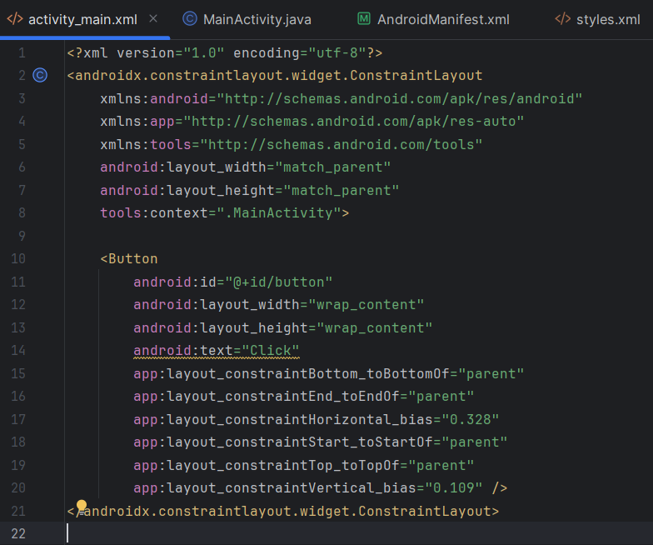

**Configuring styles.xml (For Custom Theme/Style)**

**Location:** res → values → styles.xml

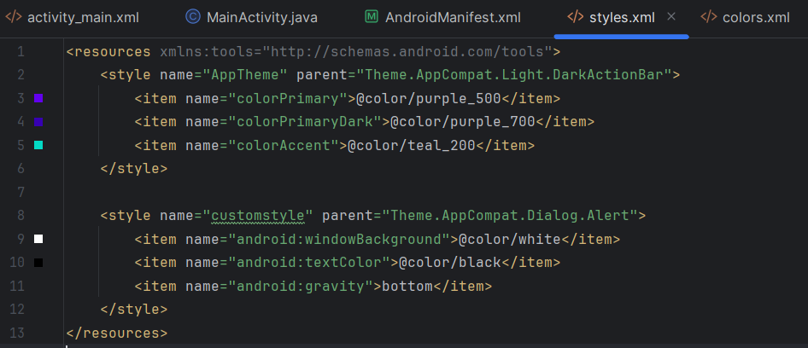

• Open strings.xml from res → values.

Add string values for app name, alert title, message, and button text

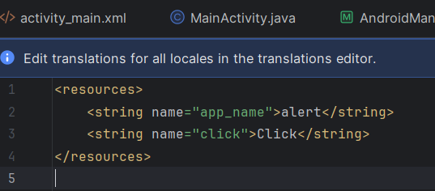



**Implementation Phase: Final Output(no error)**

Open AndroidManifest.xml in the app → src → main folder.

add android:exported="true" to the activity tag with an intent filter.

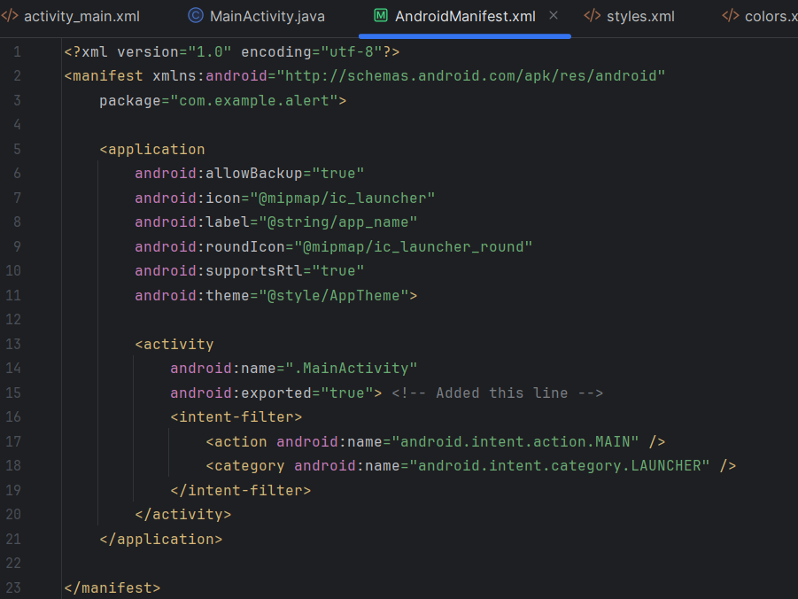

**Configuring Mainactivity.java**

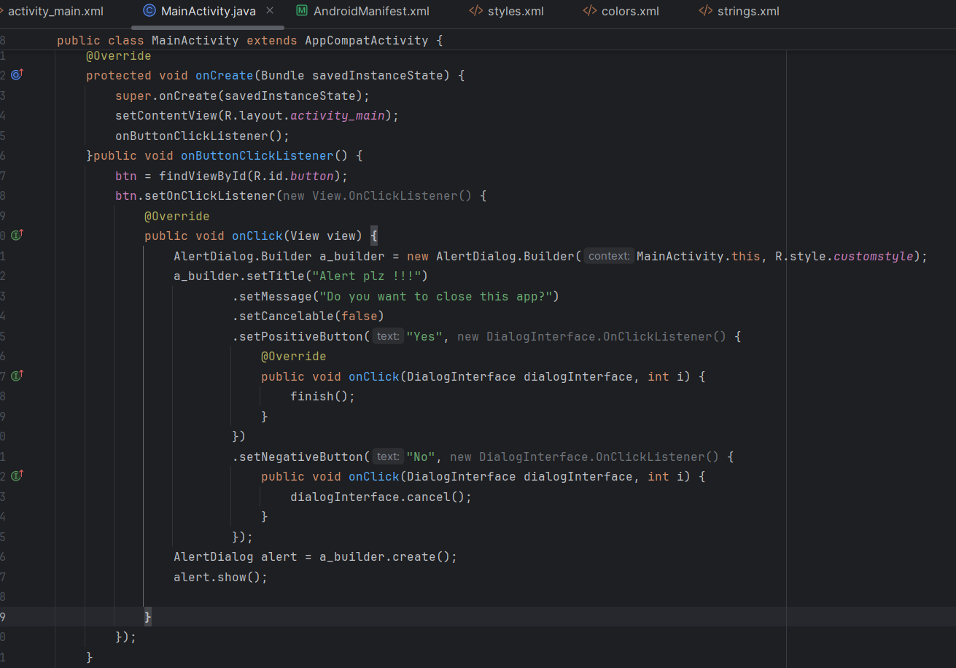



Click **Run** to test the Alert Dialog.





        
        
        
        
        
        
        
        
        



